**PRACTICAL ONE**

1. A NIC provides a computer with a dedicated, full-time connection to a network. It implements the physical layer circuitry necessary for communicating with a data link layer standard, such as Ethernet or Wi-Fi. Each card represents a device and can prepare, transmit and control the flow of data on the network.

**FUNCTIONS OF NIC**

1. NIC card can transmit signals at the physical layer and deliver data packets at the network layer
2. it acts as a middleman between a computer/server and a data network
3. When a user requests a web page, the LAN card gets data from the user device, and sends them to the server on the internet, then receives the required data back from the Internet to display for users.
4. Optical fibre is made up of plastic and glass and is used to transmit signals in light or optics whereas coaxial cable is made using plastic and copper wires and is used to transmit signals in the form of electric signals.

**PRACTICAL TWO**

1. A local area network is a computer network that interconnects computers within a limited area such as a residence, school, laboratory, university campus or office building. By contrast, a wide area network covers a larger geographic distance and generally involves leased telecommunication circuits.

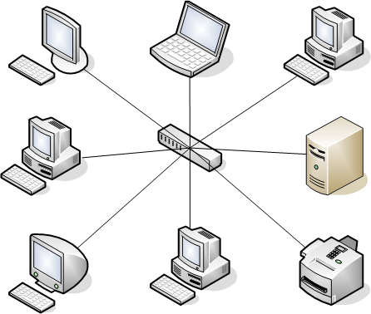’’’

1. Open the Control Panel.
2. Click on Network and Sharing Center.
3. Choose Change adapter settings.
4. Right-click on the connection whose IP address you want to assign manually and select Properties.
5. Select Internet Protocol Version 4 (TCP/IPv4).
6. Click on the Properties button.
7. Select the option "Use the following IP address".

**PRACTICAL THREE**

* 1. The below-mentioned commands are some of the most useful commands required to troubleshoot network problems and configure network settings.
     1. IPCONFIG.
     2. NSLOOKUP.
     3. HOSTNAME.
     4. PING.
     5. TRACERT.
     6. NETSTAT.
     7. ARP(Address Resolution Protocol)
     8. SYSTEMINFO.
     9. Go to search in the taskbar and Type “cmd” to bring up the Command Prompt.
     10. Open the Command Prompt.
     11. Type “ping” in the black box and hit the space bar.
     12. Type the IP address you'd like to ping (e.g., 192.XXX.X.X).
     13. Review the ping results displayed.

**PRACTICAL FOUR**

1. The IP address uniquely identifies every device on the internet; without one, there's no way to contact them. IP addresses allow computing devices (such as PCs and tablets) to communicate with destinations like websites and streaming services, and they let websites know who is connecting.

Classes of IP addresses.

Currently, there are three classes of TCP/IP networks. Each class uses the 32-bit IP address space differently, providing more or fewer bits for the network part of the address. These classes are class A, class B, and class C.

1. A subnetwork or subnet is a logical subdivision of an IP network. The practice of dividing a network into two or more networks is called subnetting. Computers that belong to the same subnet are addressed with an identical most-significant bit-group in their IP addresses.

**PRACTICAL SIX**

1. The common protocols for email delivery are Post Office Protocol (POP), Internet Message Access Protocol (IMAP), and Simple Mail Transfer Protocol (SMTP). Each of these protocols has a standard methodology to deal with the emails and also has defined functions.
2. In the Internet, a domain name is a string that identifies a realm of administrative autonomy, authority or control. Domain names are often used to identify services provided through the Internet, such as websites, email services and more. As of 2017, 330.6 million domain names had been registered.

### Top-Level Domains (TLDs)

### Country code top-level domains (ccTLD)

### Internationalized country code top-level domains (IDN ccTLD)